**A Closed-Loop System for Treating Freeze of Gait in Parkinson's Disease**

**Problem Statement**

Freeze of Gait (FOG) in Parkinson's Disease patients, affecting 35%, poses a critical challenge by increasing fall risk and reducing mobility, highlighting the need for innovative solutions.

**Our Solution: A Closed-Loop System**

We propose a closed-loop system that uses signal processing and machine learning to detect and mitigate Freeze of Gait (FOG) episodes in Parkinson's Disease patients through real-time auditory interventions, aiming to improve their mobility and quality of life.

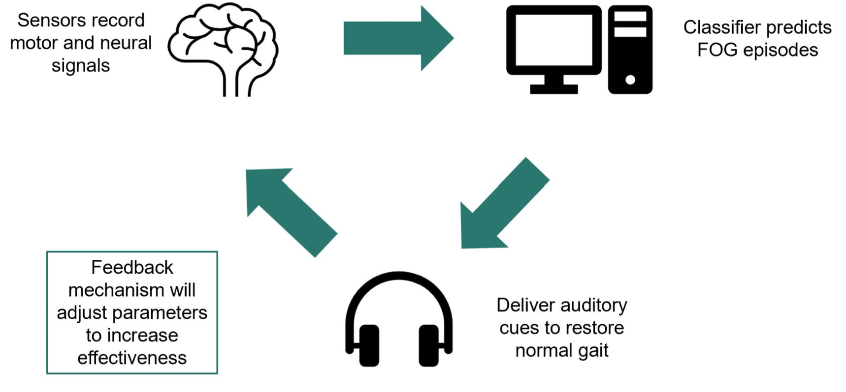

**Target Users**

Individuals diagnosed with Parkinson's Disease who experience Freeze of Gait. Our system aims to empower these patients with improved mobility, independence, and overall quality of life.

**Potential Impact**

- Significant Reduction in the frequency and duration of FOG episodes.

- Enhanced Patient Outcomes: Improved mobility, independence, and quality of life.

- Innovation in PD Care: Addressing a critical gap in Parkinson's Disease treatment and management.

**Questions & Concerns**

- Feasibility/User Adoption/Clinical Validation